Time Doctor – Report file generation steps – DM

Refer this page: <https://support.timedoctor.com/knowledge/the-web-app-usage-report>

To export data user-wise with Site/ apps accessed

**Login to Time-Doctor Dash-Board**

<https://2.timedoctor.com/dashboard>

**Settings** Tab **🡪** select **Company Settings 🡪 Web & App Privacy 🡪** Reporting Type is **Basic / Extended**

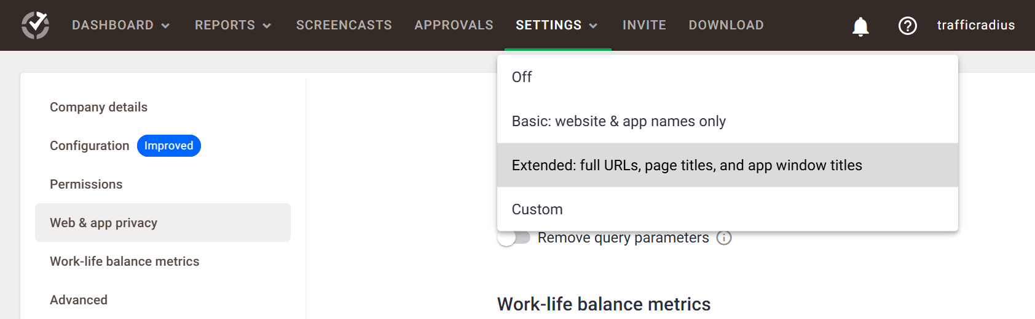

Generate 1st Report **Hours Tracked Report** for **a Month**

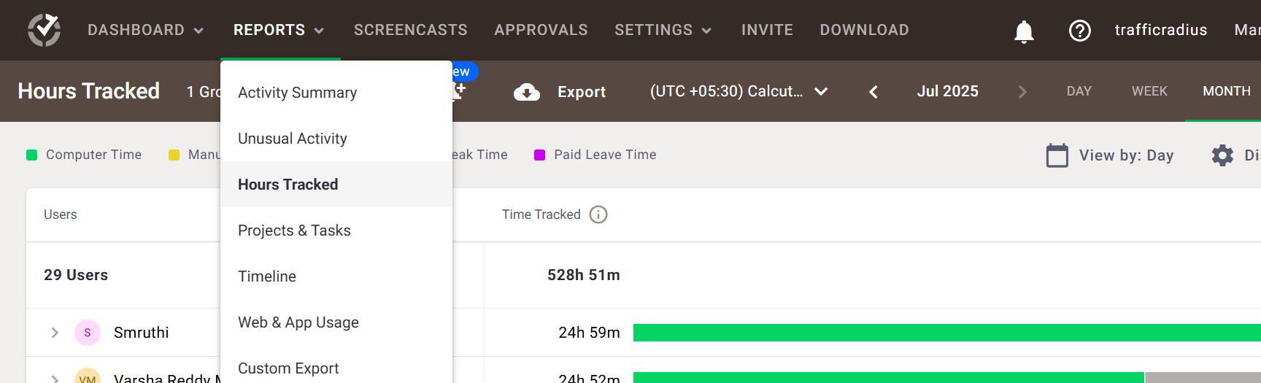

**Will get the report like this format (with Daily basis & Month report)**

**Paste this Report in a Template Report Workbook & in the “ Hourly Tracked ” Work-Sheet**

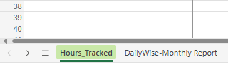

Generate 2nd Report **Custom Export Report** for a **Month**

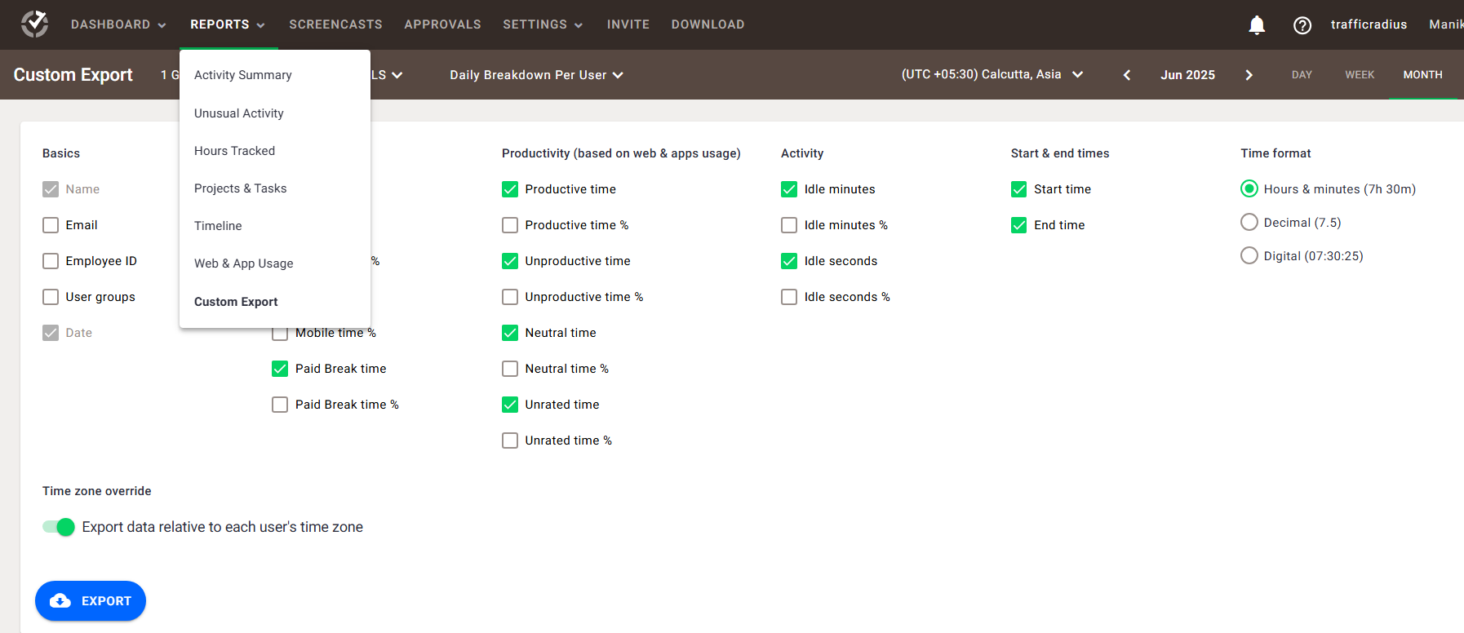

& Select the Options / Column headers like below

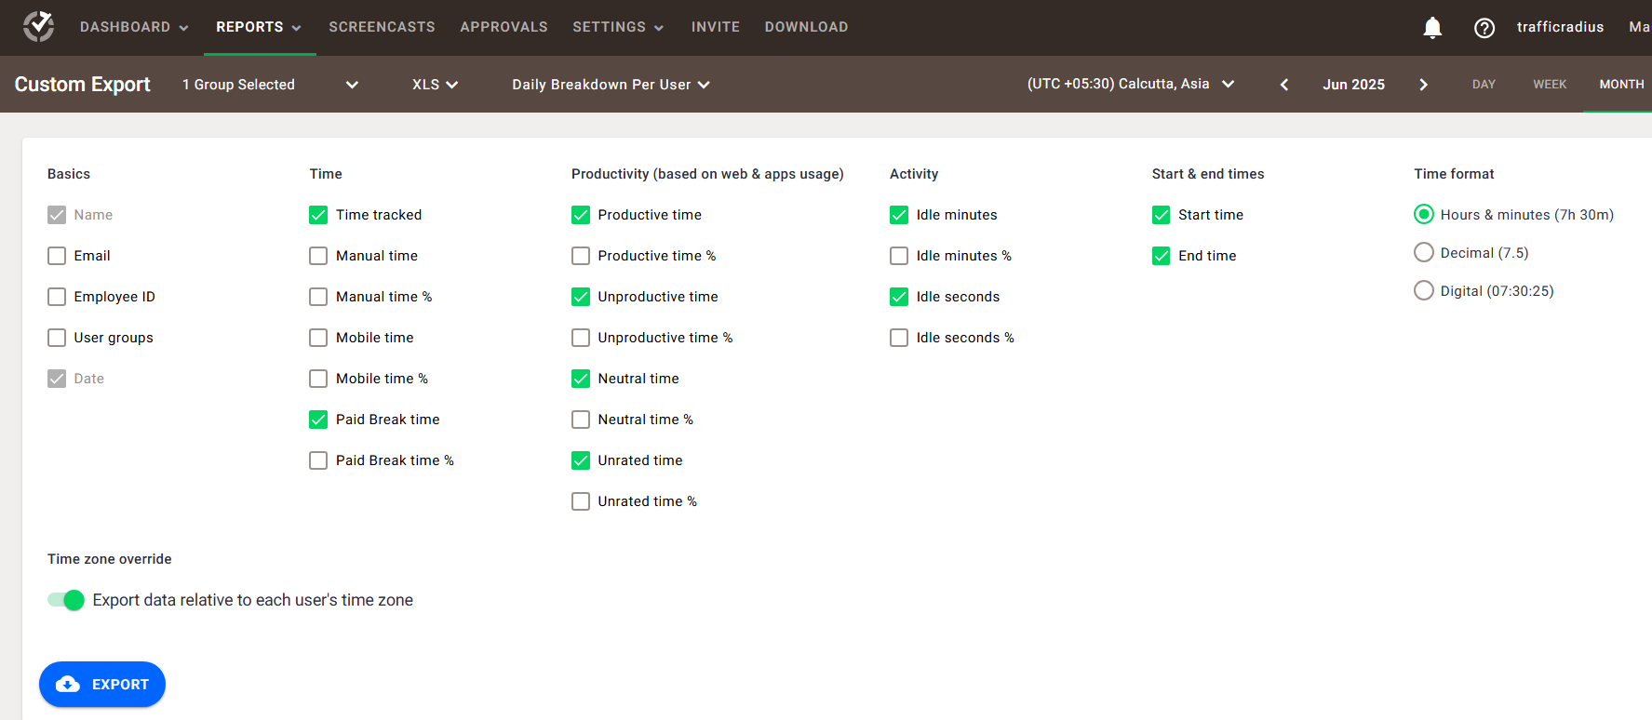

**Paste this Report in a Template Report Workbook & in the “ DailyWise-Monthly Report ” Work-Sheet**



**Will get the report like this format**

Generate 3rd Report **Web & App Usage Report** for a **Month** 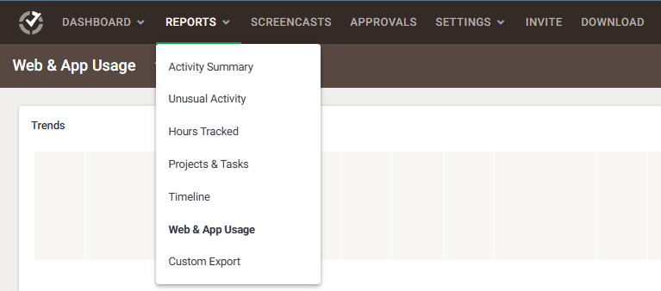

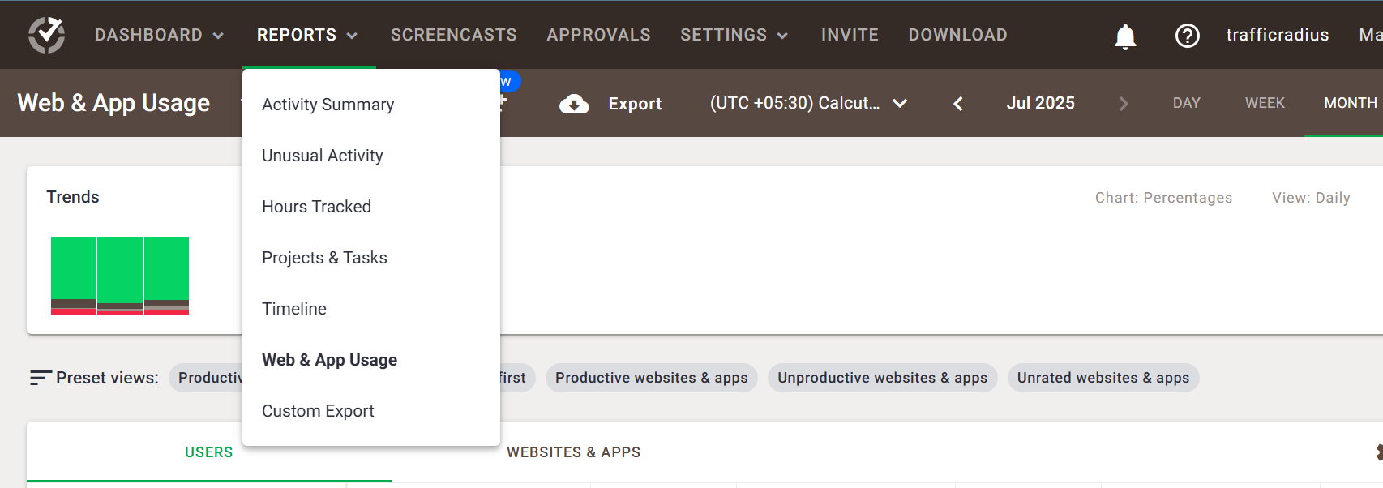

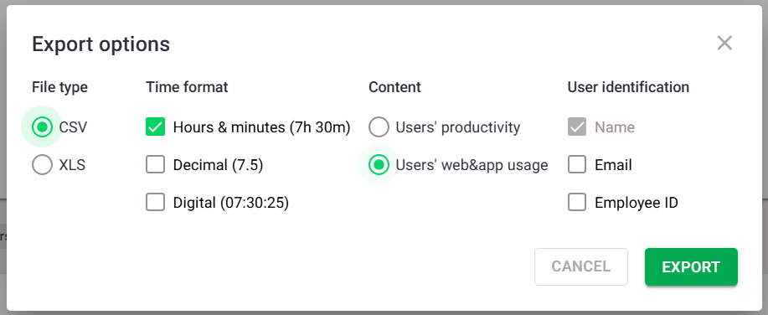

**Will get the report like this format**

**Consolidate both (2nd & 3rd) Report in a Template Report Workbook & in the “ DailyWise-Monthly Report ” Work-Sheet below the 2nd report Data.**

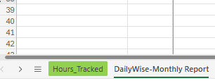 **So Finally, Report will generate automatically Daily-Wise for a month**